Bohm velocity criterion and a highly collisional plasma in Debye/Langmuir Sheath

*A.Kosykhin, York Plasma Institute*

*Mizpeling hghg.*

**Abstract:**

*The plasma sheath is a layer in a plasma which has a greater density of positive ions. It arises because positevly charged carries, ions, are attacted to a negatively charged surface and screen out the negatively potential. Here we simulated the physical process and wrote a computer code in Python and numirecally calculated main plasma parametres as potential, electrical field and current. In addition we investigated some hypothetical situations, particularly, when ions have ultrashot collision length. We used Python code to investigate how the ion velocity,and flux into the wall depends on parameters in the model. Also we questioned whether formation of a plasma sheath is possible if plasma is highly collisional.*

**Introduction**

In this paper we investigate a situation when plasma has contact with material surfaces which conduct electricity. As electrons are much lighter and quicker ions, at first instance electrons will contact and absorb by the surface first and charge the surface with negative charge. A current flow will appear. Shortly the after the negatively charged surface will repeal electrons and attract positively charged ions. As more ions come closer to the surface, the positive charge appear and screen out the surface from the rest of the plasma. The process is called “Plasma or Debye/Langmuir Sheath.”

**Mathematical model of simulation of the process**

We simulated the physical process with a computer code in Python and numerically calculated main plasma parameters as potential, electrical field , current and ion velocity. $To simplify we assumed that the process happens in 1 dimential space and the plasma will$ obey following: 1) Ion continuity equation: $n_{i}{\left(x\right)v}_{i}\left(x\right)= n_{s}v_{s}, where n_{i} is the ion density,$

$n_{s}$ is electron density at the beginning of the sheath.

2) Electron density $n_{e}\left(x\right)= n_{e }exp⁡(Φ$ (x)/ $T_{e}$, and ion density $n_{i}$ ( $x)$ = $\frac{v_{s}}{V_{s (x)}}$. where $n_{e}$ and $n_{i}$ are electron and ion densities at the beginning of the Sheath, $T_{e}$ is electron temperature.

3) We take into account Poisson equation = e((x) - (x)/)/

4) Instead of conservation energy formula we used $\frac{dV}{dx}$ = $\frac{E}{V_{i}}$- $\frac{V_{i}}{L}$, where ${ V}_{i}$ is ion velocity, then we get (1) $\frac{{dV}_{i}}{dx}= \frac{e}{m_{iV_{i}}}E- \frac{V_{i}}{L}$.

After normalising all variables and introducing some constants (2) $λ_{D}=\sqrt{\frac{ɛ_{0 T_{e} }}{m_{i}}}$ is Debye length and $c_{s}$ = $\sqrt{\frac{eT_{e}}{m_{i}}}$- is ion sound spead, we got a system of 3 differential equations of first order:

$\left(3\right) \left\{ \begin{aligned}\frac{dE}{dx}= -\exp\left(Φ\right)-\frac{v_{s }}{V_{i}} - This is equation for electric field \\ \\ \frac{dΦ}{dx}= E - This is equation for potential \\ \\ \frac{dV_{i}}{dx}= \frac{E}{V_{i}}- \frac{V_{i}}{L} - This is equation for length collison \end{aligned}\right.$

Also we write down the formula for current flow:

j(x) = $j_{0}$ [exp $(Φ$) – 1], where $j_{0}$ is current flow atbeginning of the sheath.

**Numerical results**

After solving this this system of equation (3) by Python code we get a numerical solution for potential, electric field, and velocity. On Fig. 1, we show a graph of potential, electric field and current flow. On Fig 2 we show ion velocities at different ion collisional length, the small graph on Fig. 2 shows dependence ion velocity at the wall from collisional length. It clearly shows the shorter ion collisional length, the lower ion speed at edge of the material wall.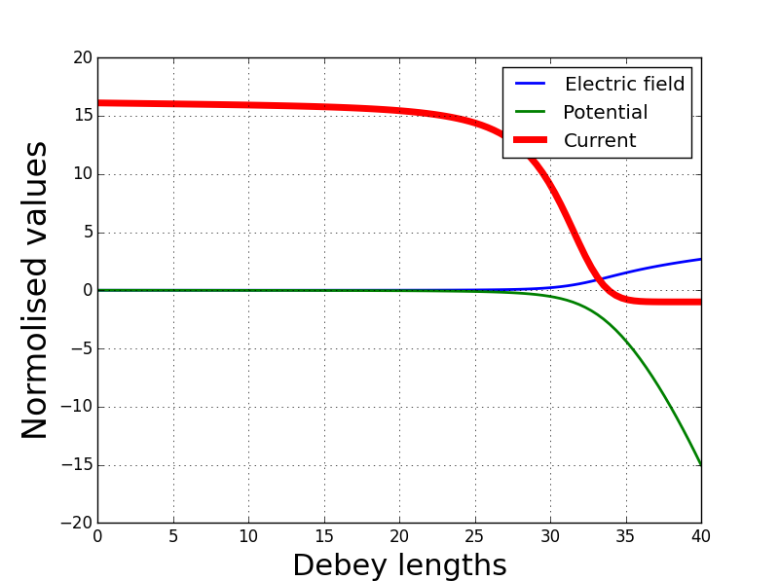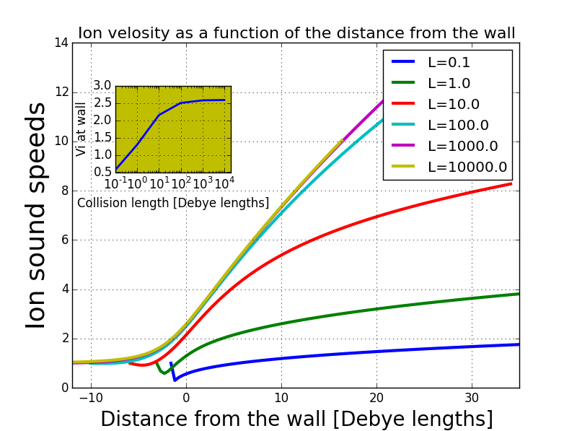

Figure 1 Figure 2

In addition here we make attempt to understand which criteria the plasma should satisfy for forming the Debye Sheath. For this purpose we started gradually decreasing ions length collisions. As we see from Fig. 2, as length collision decreases frequency of ion collision and lose their energy increases. It becomes much more difficult for ions to speed up and high reach speed. Presumably they hit the material wall with less and lessvelocity. Nevertheless, shape potential, electric field and current remain the same.

**The process at very shot ion collisional lengths**

But when we reduced in the Python code the ions length to 0.0002 of Debye lengths, the situation changed dramatically. Here we compare Fig 3 and 4. On Fig 3 when ion collisions happen relatively rarely, ion velocity slowly increases. Potential and electric field also increases in their values. Current flow at the edge of the wall approaches its negative value. The graphs are smooth. On Fig 4 the situation is dramatically different. Ion velocity is quickly going to zero. Potential and electric field are approaching zero inside the wall. Their graphs look unnaturally symmetric relatively the edge of the wall.

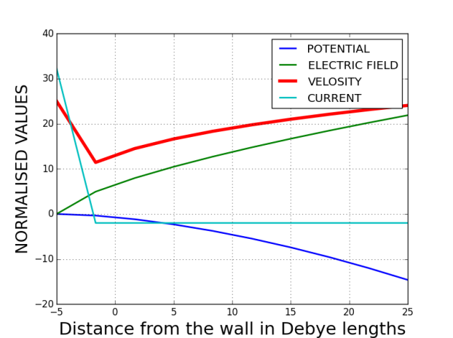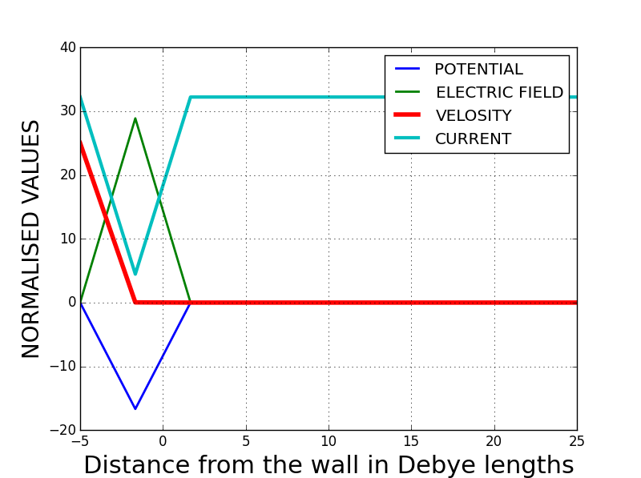

Figure 3 (rare ion collisions) Figure 4 (frequent ion collisions)

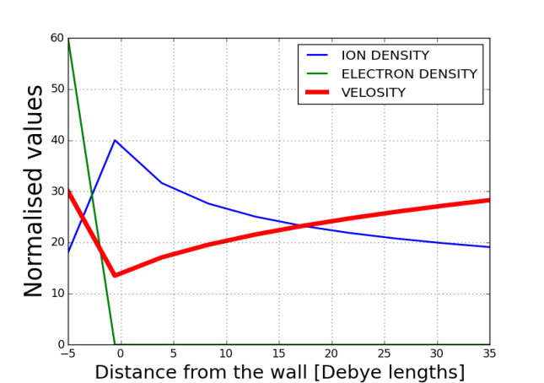 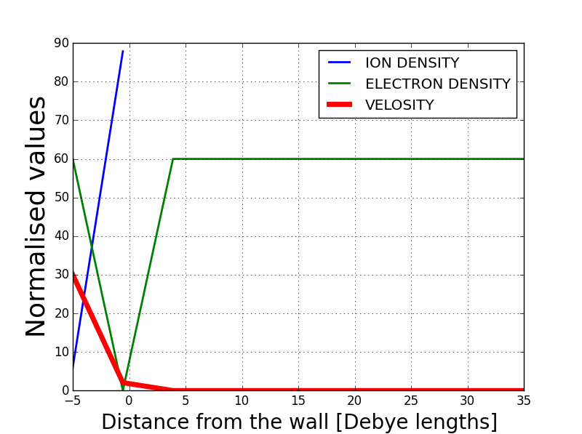

Figure 5 (Rare ion collisions ) Figure 6 (Frequent ion collisions)

To answer what is really happening near the wall when ion collisions are frequent, we decided to calculate electron and ion densities at edge of the wall. For this we used formulas from our mathematical model. Electron density is $n_{e}(x)$ = exp(Φ(x)), and ions density is $n_{i}$ ( $x)$ = $\frac{v_{s}}{V_{s (x)}}$. We compare ion and electron densities on Figure 5 and 6. They are absolutely different. On Fig. 5 electron density is going to zero at the edge of the wall and electrons don’t penetrate into the material. But ion density increases as long they approach the wall, and eventually, they come inside the wall. But Fig 6 shows an absolutely different picture. Ion density increases up to the edge of the wall, but it looks like they don’t approach the wall and spot in the middle. The graph shows there are ions inside the wall. It looks like ions don’t have energy enough to approach the wall, because of their frequent collisions. We can suggest that formation of Debye/Langmuir sheath doesn’t happen here.

**Bohm velocity criterion**

It resembles a situation described by Bohm when he suggested that in some situations formation of Debye/Langmuir sheath cannot be possible because of low ion velocity. He stated that ions need to have a minimum velocity before they can enter the sheath region. He came up to this conclusion suggesting that equation (4) has to have a physical meaning.

$\left(4\right) \frac{d^{2}Φ(x)}{{dx}^{2}}$ = $\frac{en_{s}}{ɛ_{0}}$ $\left(\left(\exp\left(\frac{eΦ(x)}{kn_{s}}\right)\right)-{\left(1- \frac{eΦ(x)}{E_{s}}\right)}^{{-1}/2}\right)$

where $E_{s}$ = $\left(1/2m_{i }v_{s}^{2}\right)$ is defined as initial ion energy of the edge. Solution of equation (4) is possible if following inequality (5) takes place:

(5) $\frac{{eΦ(x)}^{2})}{eT_{e}}$- $\frac{{eΦ(x)}^{2})}{4E_{s}}$ ≥ 0, from this follows (6) $v_{s}≥ {\left(\frac{kT_{e}}{m_{i}}\right)}^{1/2}$

This *vs* is defined as Bohm velocity – the minimal ion velocity of the sheath edge and this is known as the Bohm criterion for sheath formation. The Bohm model was for a cold plasma and he did not consider highly collisional plasma. But it is obvious that in both situation, a cold plasma and highly collisional plasma, ions have low velocity when they enter the edge and formation of the Debye/Langmuir sheath does not occur.

However a question arises what is the physical meaning of equation (4) at very low $v_{s}$.

It was speculated that Bohm’s mathematical model was not correct enough and physics of plasma waves had to be taken into consideration, which takes place even at ultra-cold plasma.

**Conclusion**

Our mathematical model of the Debye Sheath and its numerical solution explains the physics of the Debye Sheath matches experimental results. However, I admit, it has some limitations.   Particularly, it is not clear enough what actually happens when a plasma is ultra-cold or highly collisional.  It is possible that the Debye Sheath disappears or plasma ions wave will be dominant in the process. Some extra equations should be added or replaced, when the plasma has such extreme parameters to clarify the situation.

**References**

1) //en.wikipedia.org/wiki/Debye_sheath and lecture notes by R.Fitzpatrick <http://farside.ph.utexas.edu/teaching/plasma/lectures/node41.html>.

2) “Waves in Cold Plasmas” by Richard Fitzpatrick 2011-03-31

<https://farside.ph.utexas.edu/teaching/plasma/lectures1/node41.html>

3) Kinetic Theory of the Presheath and the Bohm Criterion”

S D Baalrud‡ and C C Hegna Department of Engineering Physics, University of Wisconsin-Madison, 1500 Engineering Drive, Madison, WI 53706, USA